**Techincal challenge Blog Assignment**

When I created the model, I faced the first problem. To use machine learning I need to have cyclical data .For example Time. I chose one day to have a look at the time around midnight.

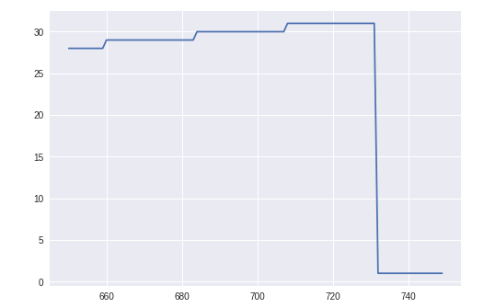

when the time goes from 23 to 0 we have a jump, so there is a problem about presenting cyclical data to machine learning algorithm.

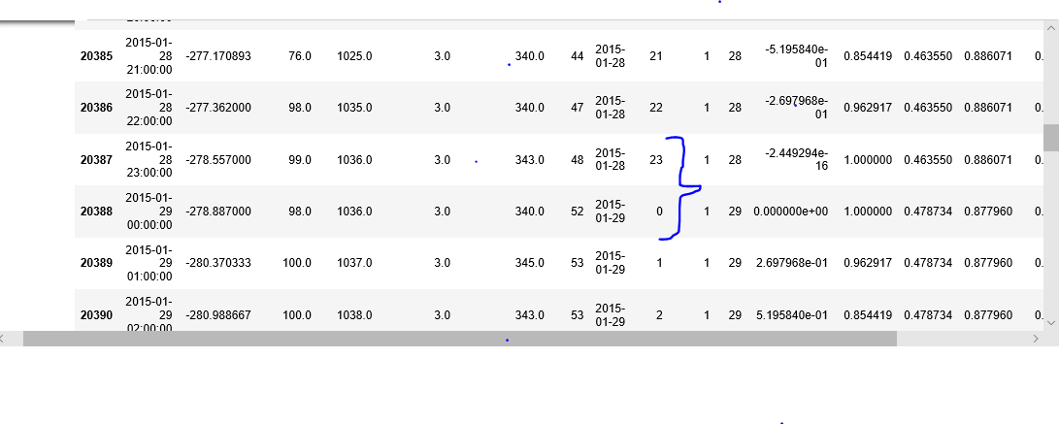

between record "20387" and 35 : 23-22=1

between record "20388" and 36 : 0-23=-23

so we need to change the encoding of the feature. A common method for encoding cyclical data is to transform the data into two dimensions using a sine and cosine transformation. We need to see a cycle between 0 and 23. We can do that using the following transformations:

*xsin*=sin(2∗*π*∗*x*max(*x*))

*xcos*=cos(2∗*π*∗*x*max(*x*))

Let's do this for our hourly data by defining a function :



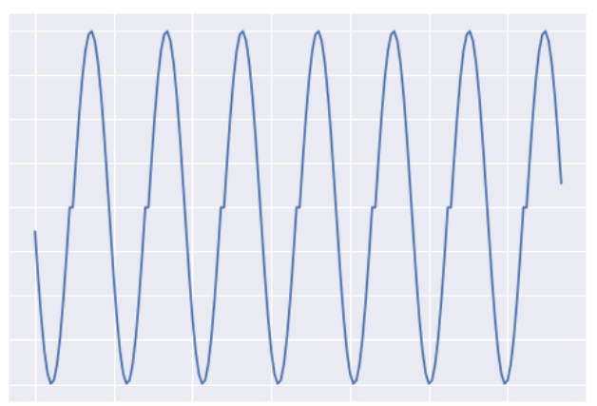

Why two dimensions, using sine and cosine you may ask? Let's have a look at just one dimension:

As expected, it is cyclical, based on the sine graph. Looking at the values around midnight again:

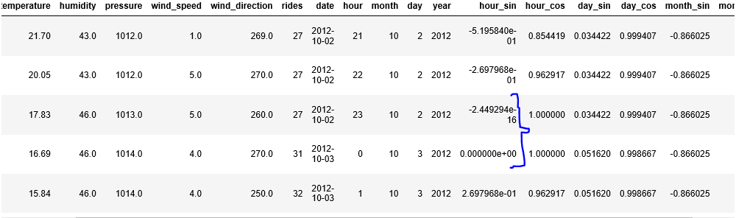

Great, it appears the absolute difference an hour_sin before, at and after midnight is now the same! However, if we look at the plot of hour_sin (following any flat line intersection with the graph), we can see there is a problem. If we consider just the one dimension, there are two records with exactly the same hour_sin values, This is why we also need the cosine transformation, to separate these records from each other.

Indeed, if we plot both features together in two dimensions we get the following:

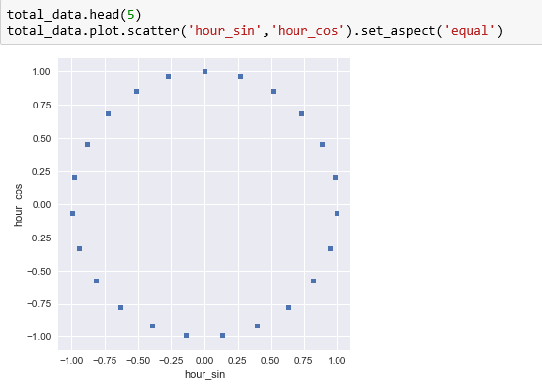

Now I can fit them in to the model. It supposes to have better results with cyclical data so I will try my model with both. For example I will try Regression.

First of all, this data set has been split to train and test.

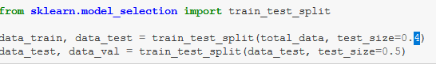

Then I try the model with cyclical and non cyclical features. After evaluation of each model I got the result below:

Cyclical : 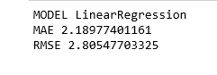

Non cyclical: 



**Conclusion :**

It's important to encode features correctly for the specific machine learning algorithm being used. Other machine learning algorithms might be robust towards raw cyclical features, particularly tree-based approaches. However, deep neural networks stand to benefit from the encoding strategy discussed above, particularly in terms of the convergence speed of the network.